**Task 4**

**User Guide**

User Guide for [Online Examination Portal]

[November 2022]

**Instructions:**

* Change everything that is in brackets []
* Add your practical project content to the document
* Make sure that your Table of Content is updated
* Update the document revision table
* Complete all the Process and Process Steps for your practical project in this document

Document Revisions

|  |  |  |
| --- | --- | --- |
| Date | Version Number | Document Changes |
| 07/06/2022 | 0.1 | Initial Draft |
| 07/07/2022 | 0.2 | Document Changes |
| 07/08/2022 | 1.1 | System Plan |
| 10/08/2022 | 1.6 | Development and Coding |
| 10/09/2022 | 2.0 | Database Formulation |
| 11/10/2022 | 2.5 | Program Compilation |
| 15/11/2022 | 3.0 | Program Analysis and Final Draft |
|  |  |  |
|  |  |  |

Table of Contents

Introduction 6

Scope and Purpose 6

Quick Start Guide 7

Appendices 9

Index 10

Student Portal 10

Lecturer Portal 10

Exam Department Portal 10

# Introduction

## Scope and Purpose

* **Introduce the practical project and its purpose**.

The Online Exams Submission System provides an efficient way to manage exam papers and helps to assure exam paper security through electronic processes for the creation, transfer, and approval of test papers. The System allows academic staff to submit exam papers online for review by a co-examiner, who can then accept or reject the paper depending on whether adjustments are required. The System provides access to approved papers to assessment workers who produce the papers for the relevant examination session. The University portal and the Online Exams Submission System have direct contact. The objectives of online examination system or rather any other exam (purpose of online examination system) is to make sure that the student is thoroughly ware of the course curriculum and that the exam reflects the course content he/she has studied.

* Highlighting **key features and benefits**.

Mapping your course content and exam questions is paramount to teaching and education. It’s what gives us the satisfaction that we’re on track and that what was intended to be taught and addressed in questions is done.

* Introduce the **purpose of the user guide**.

Design is the first step in the development phase for any techniques and principles for the purpose of defining a device, a process or system in sufficient detail to permit its physical realization. Once the software requirements have been analysed and specified the software design involves three technical activities - design, coding, implementation, and testing that are required to build and verify the software. Online examination system project. The design activities are of main importance in this phase, because in this activity, decisions ultimately affecting the success of the software implementation and its ease of maintenance are made. These decisions have the final bearing upon reliability and maintainability of the system. Design is the only way to accurately translate the customer’s requirements into finished software or a system.

## Quick Start Guide

**Provide an overview of the functionality of the practical project and how the user will interact with the practical project.**

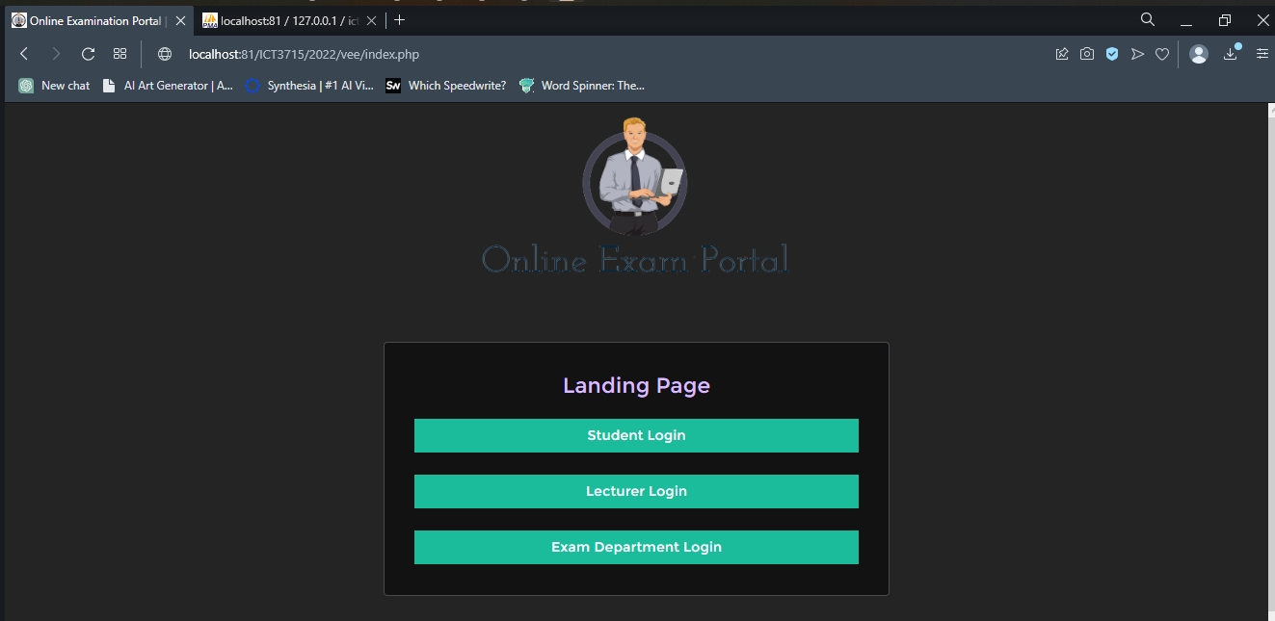

This is the landing page with different section to the system

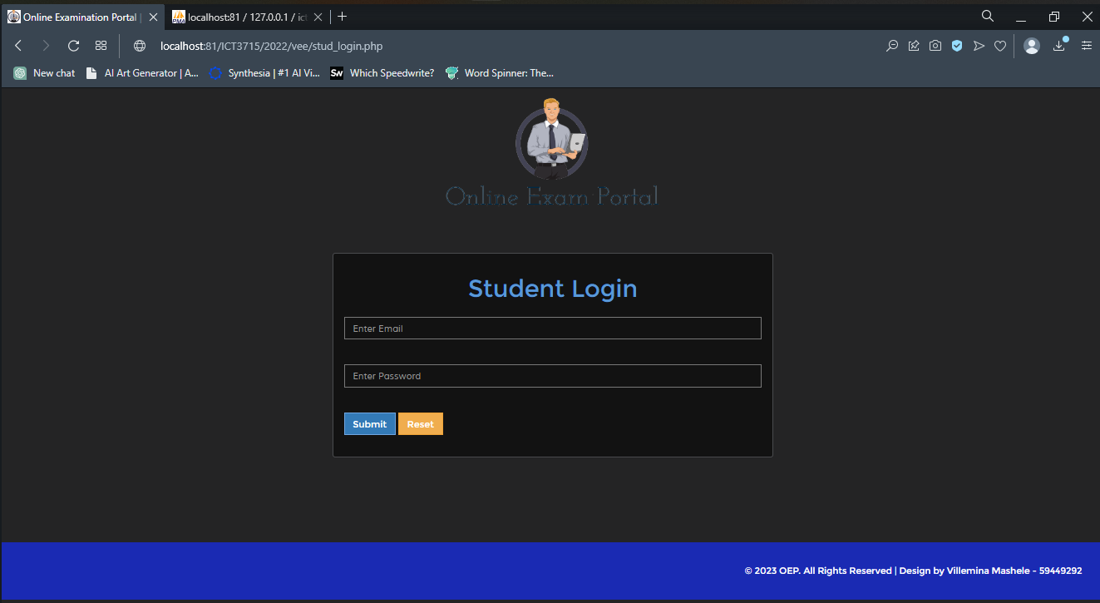

Student login page

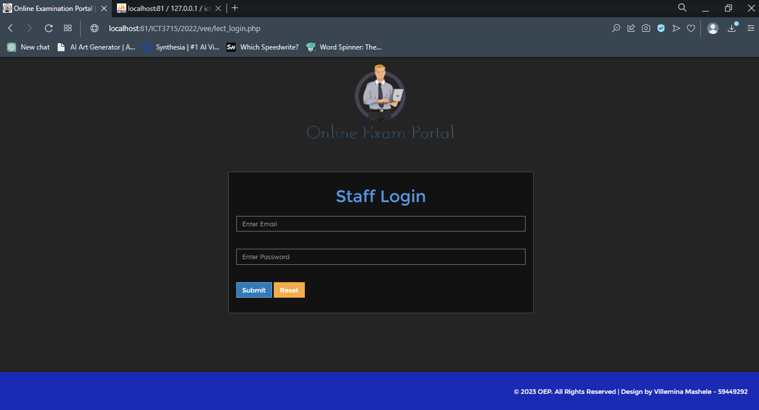

Staff login page

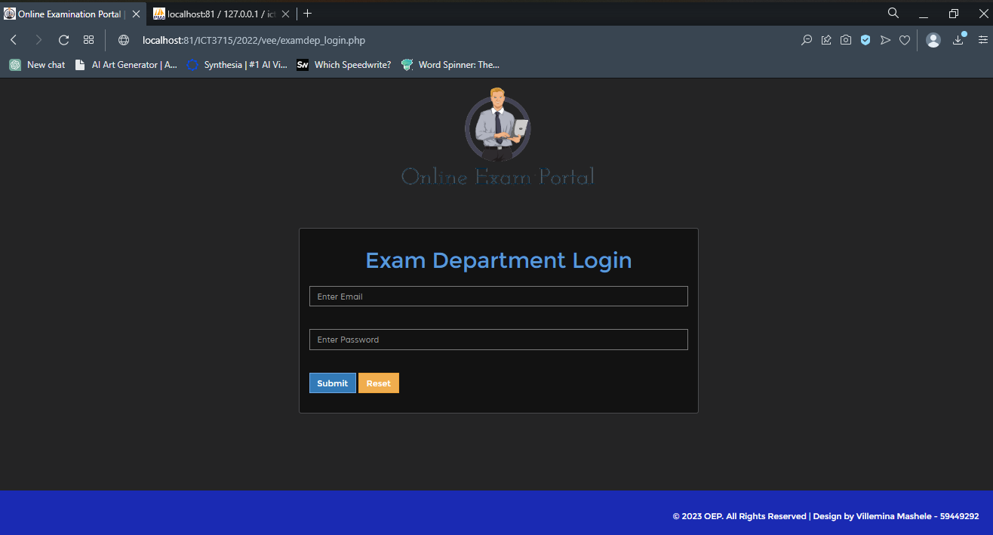

Exam Department Login

# Appendices

When you test PHP code locally, you can check your PHP scripts for both functionality and errors. Your best option is using XAMPP through your web browser to run your PHP scripts. If you prefer, there are online services available to find errors within your PHP code. If you choose to use XAMPP, follow the steps below.

**Step One**

Make certain XAMPP is installed. This is one of the most frequently used PHP testing environments for Mac and Windows computers. XAMPP can be downloaded and installed for free.

**Step Two**

If XAMPP is running, close it. Your htdocs folder can now be updated with no interference from the existing processes. If you are using a MAC, skip this step.

**Step Three**

Put your PHP files into your htdocs folder. If you are using Windows, open the folder labelled My PC. Double-click on the name of your hard drive, then your xampp folder and finally your htdocs folder. You need to move all required PHP files into your folder. If you are using a Mac, go to your XAMPP control panel and click the Volumes tab. Now click Mount, then Explorer and double click on your htdocs folder. Once again, move all required PHP files.

**Step Four**

Double click on your icon for XAMPP or open your XAMPP. Look for an orange background with a white X.

**Step Five**

Just to the right of your Apache heading, you will see the Apache web server. Click on Start. There is an indicator to your right that should turn green.

# Index

## Student Portal

* Login – (Validations with database)
* Dashboard – Landing for successful login
* Calendar – View calendar using month view
* Start Exam – Download the exam paper using a link
* Upload Exam – Upload the paper with timer displayed
* Profile – View my Information
* Logout

## Lecturer Portal

* Login – (Validations with database)
* Dashboard – Landing for successful login
* Calendar – View calendar using month view
* View Information – details the module and lecturer information
* Student - View Student Information registered for the module the lecturer is handling
* Profile – View my information
* Logout

## Exam Department Portal

* Login – (Validations with database)
* Dashboard – Landing for successful login
* Calendar – View calendar using month view
* Report 1, 2, 3, 4
* MIS Report 1, 2, 3
* Profile – View my information
* Logout